1. Which is better higher true Negative or Higher True Positive?

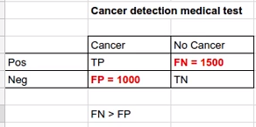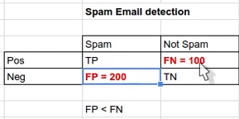

1. What is interpolation and Extrapolation?
2. What are advantages and disadvantages of using Neural Nets?

|  |  |
| --- | --- |
| Advantage | Disadvantage |
| Deep Learning  Image, Video, Text  Create abstraction to data | Needs huge amount of data  Difficult to debug  Architecture is complex  GPU, Training Time |

1. What are various dimensionality reduction techniques?
2. Removing features with low variance
3. Removing collinear features
4. Combining features
5. PCA, LDA
6. How is KNN different than K-Mean?

|  |  |
| --- | --- |
| KNN | K-Mean |
| Supervised, Classification, Required Label | Unsupervised, Clustering, No Label Required |

1. Type -1 and Type-2 Error?

False Positive is Type -1 Error

False Negative is type-2 error

1. Difference between Generative and Discriminative Models?
2. What is Bias Variance Tradeoff?

|  |  |
| --- | --- |
| Bias | Variance |
| Lots of assumptions  Less Complex Model  Underfitting  Test will be good but training will be bad  High Bias + Low Variance | No Assumption  Complex Model  Overfitting  Training will be good, Testing will be bad  Low Bias + High Variance |

1. Collaborative Filtering and Content based Filtering?
2. What is regularization and why is it required?
3. What is K-fold Cross validation?
4. Why not use Deep learning for every problem?

Deep learning models are like BlackBox.

1. How do you calculate performance of ARIMA model? Answer: - Mean Absolute Error.